DIY Mini-Airboat — Design Summary
Oct 26, 2026 · @Buzz
A 12.5 ft riveted-aluminum airboat for solo python hunting and light cargo in the Everglades, powered by a junkyard Suzuki G13 through a DIY HTD belt redrive: about 39 mph top speed, 30 mph cruise and roughly 45–55 miles on a 6.6 gal tank. The floor sits low on the stringers, every bay drains to a transom sump, and the foam is in removable blocks, so leaks show up and can be found. Swamped, it floats awash with at least 3.5 in of freeboard, enough to steady it and pump it out in calm water. Every joint is now detailed for fabrication (rev 6). Materials come to about $18,700 with contingency; the build is about 450 DIY hours.
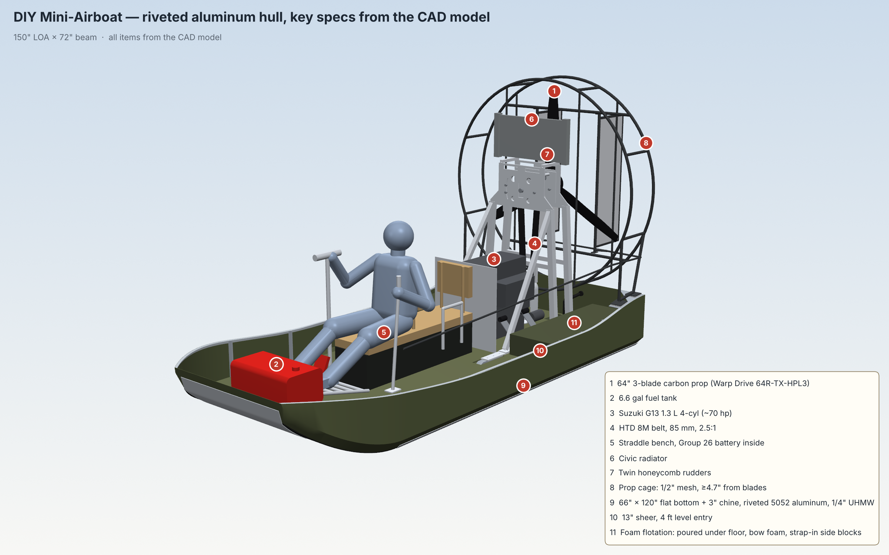

At a glance
The boat is 150 in long on the hull, 72 in wide and about 7 ft 5 in tall at the top of the prop cage, and weighs about 1,040 lb empty.
Item | Value
Hull length / beam | 150 in / 72 in
Overall length incl. rudders | about 168 in (14 ft)
Overall height (top of cage) | about 89 in
Hull construction | Riveted 5052 aluminum: 0.090 in bottom, chine and bow face; 0.063 in sides; 0.125 in transom
Planing bottom | 66 × 120 in flat, 1/4 in UHMW in 4 strips
Chines | 45°, 3 in rise, constant along the hull; aluminum guard angle on the edge
Bow | Johnboat style, 45 in wide, 6 in tall, 15° forward lean, 30 in constant-radius rocker (R ≈ 40 in); all panels single-curve
Sheer | 18 in at transom, curves to 13 in level for 48 in (entry zone), curves back to 18 in at bow
Engine | Suzuki G13 1.3 L 4-cyl (junkyard), about 70 hp
Reduction | HTD 8M belt, 85 mm, 30T / 75T = 2.5 : 1
Prop | Warp Drive 64R-TX-HPL3, 64 in, 3-blade carbon, ground-adjustable, stoneguard edge
Prop hub height | 52.5 in (disk clears the 18 in transom by 2.5 in)
Seating | Low straddle bench, driver + 1 passenger, removable backrests
Fuel | 6.6 gal portable tank on a bow shelf
Weight empty (no fuel or crew) | about 1,040 lb (CAD) plus about 30 lb of rivets, sealant, paint and wiring
Weight solo, full fuel | about 1,280 lb
Flotation | about 16 ft³ of removable foam blocks (aft, bow and sides) plus a sealed bench; floats awash with at least 3.5 in of freeboard when swamped

Performance
Solo with full fuel the boat should reach about 39 mph and cruise at 30 mph, burning roughly 3.2–4 gph; plan on 45–55 miles per tank. Estimates are ±15% on open water.
Estimate (open water) | Solo, full fuel (1,280 lb) | Two-up, full fuel (1,480 lb)
Static thrust | about 340 lb | about 340 lb
Top speed | about 39 mph (35–43) | about 38 mph
Time to plane (0–15 mph) | about 4 s | about 5.5 s
Thrust margin over the planing hump | about 100 lb | about 65 lb
Cruise speed | 30 mph | 30 mph
Power used at cruise | about 33 hp | about 35 hp
Fuel burn at cruise | 3.2 gph calculated, 3.5–4.5 gph real-world | about 3.4 gph calculated
Range at cruise, 6.6 gal | about 60 mi calculated; plan 45–55 mi | about 58 mi calculated; plan 40–50 mi
Economy cruise | 25 mph, 2.2 gph, about 75 mi calculated | 25 mph, 2.4 gph, about 70 mi
Fuel burn, wide open | about 6.3 gph | about 6.3 gph
How these were estimated: G13 at about 70 hp; prop thrust scaled from momentum theory with cage and rudder losses, falling about 8.5% per 10 mph; planing drag from the 66 in flat bottom (hump about 17% of weight, about 2.8° running trim) plus friction on the wider wetted bottom; air drag CdA ≈ 8 ft²; prop efficiency about 0.38 at cruise; fuel use 0.55–0.60 lb/hp-h. Compared with the stitch-and-glue hull, the aluminum hull and wider bottom plane about 0.5–1 s sooner and add about 18 lb of hump margin; top speed is about 1 mph lower because more bottom stays wet. Top speed is set by prop thrust falling to meet drag: at 39 mph about 55% of drag is water friction, 30% lift drag and 15% air drag, and the cheapest gain is more prop pitch once planing is sorted.

Hull and structure
The hull is riveted 5052 aluminum with aluminum framing and a replaceable UHMW wear bottom; it weighs about 330 lb finished (plus about 17 lb of rivets, sealant, bolts and paint). Every panel is single-curve, so each is cut flat and bent by hand or in a brake.
- Skin: 0.090 in 5052-H32 bottom with the 3 in chine bent in, bow rocker and bow face; 0.063 in sides; 0.125 in transom. One long bottom seam on the centerline over the center stringer, and one transverse butt seam with a doubler at frame 120.
- Joints: 1 in minimum laps, sealant (Sikaflex 291 or 3M 4200) wet in every lap, closed-end aluminum blind rivets 3/16 in in double rows at about 3/4 in. Expect a few weeping rivets over the years; see Finding and fixing leaks below.
- Stringers: five brake-formed hat sections, 2.5 in tall, at the centerline, ±14.8 in (0.080 in, the engine-bed stringers) and 1.6 in inside each bottom edge (0.063 in); bent to the rocker.
- Frames: 1-1/2 × 1-1/2 × 1/8 in angle following the skin at 12, 24, 36, 48, 72, 96 and 120 in, plus a transom frame; notched around the stringers, with a 1 × 3/4 in limber notch at the skin in every bay. A 1 in cross-drain slot through every stringer at x = 3.5–4.5 in lets all bays and the hat interiors drain into the port-bay sump.
- Engine beds: 2 × 3 × 1/8 in box tubes riveted on the bed-stringer hats from x = 6 to 66 in, topped with HDPE and the same 48 × 3 × 1/4 in plates as before (top 5.675 in above the hull bottom, 16 holes at 3 in spacing).
- Sheer: 1 × 1 × 1/8 in aluminum angle rub rail inside the sheer; 1/4 in plate quarter knees and frame-12 gussets under the four cage plates.
- Bottom armor: four 1/4 in UHMW strips (seams at the centerline and the bed stringers), through-bolted with sealant into the stringers; fixed at mid-length, slotted toward the ends for expansion. Aluminum guard angles capture the outer edges, and a bent nose cap covers the bow's leading edge.
- Corrosion: aluminum-only rivets, stainless isolated with Tef-Gel and HDPE, and nothing bonded to the inside of the skin: no poured foam, no wet wood. Water against foam on bare aluminum causes poultice corrosion that pits the skin unseen, so the bilge stays open, drained and inspectable.
- Coordinates used in all CAD files: x forward from the outside of the transom, y to port, z up from the outside of the hull bottom, in inches.

Drivetrain
A junkyard G13 sits low on the engine beds and drives the prop shaft through an 85 mm HTD belt at 2.5 : 1, so the prop turns about 2,400 rpm at 6,000 engine rpm; the drivetrain weighs about 385 lb with its mounts and hardware.
- Engine: Suzuki G13 1.3 L 4-cylinder (1995–2001 Geo/Chevy Metro 1.3 or 1989–2001 Suzuki Swift), crank 15 in above the hull bottom, flywheel facing aft. Crank turns counter-clockwise viewed from the flywheel, so the prop turns clockwise viewed from astern ("R" prop; confirm with Warp Drive).
- Bellhousing adapter: generic G-series plate with a starter boss; bolt pattern to be measured from the real block.
- Torsional protection: rubber flex coupling from the flywheel to a 1-1/4 in jackshaft in its own bearing housing, so belt pull never loads the crank.
- Belt: HTD 8M, 85 mm wide (a single parameter in the CAD), 30T / 75T pulleys, 37.5 in centers; use a 2320-8M (290 tooth) belt. An optional 3.5 in backside idler bolts to the adapter on the slack (starboard) side.
- Prop shaft: 1-1/2 in shaft in two flange bearings, one in each yoke plate, with the 75T pulley between them and the prop flange outboard aft.
- A-frames: two aluminum A-frame weldments at x = 13.5 and 22.5 in: 2 × 2 in legs slotted over the 3/8 in peak plate and capped, mitred crossbar, legs cut flat onto gusseted 1/4 in feet bolted 2.25 in either side of each leg. Diagonal braces run forward to the bed plates at x = 49.5 in on bolted clevises (3/8 in grade 8, removable), and tie struts bolt to tabs on the adapter and crossbar. Engine mounts at x = 31 and 42 in: 6061 cradles on the beds, steel brackets on the block, poly bushings on 1/2 in through-bolts.
- Belt tensioner: one rigid yoke carries both bearings. Each peak plate has a 1/2 in grade 8 pivot bolt (port) and an arc slot with two 1/2 in grade 8 bolts (starboard). Set tension with the 1/2-13 jack screw, tighten the slot bolts, then the pivot; the jack screw's lock nut is a positive stop.
- Prop: Warp Drive 64R-TX-HPL3, 64 in, 3 carbon blades on the HPL hub, stoneguard leading-edge protection; plane at x = 5 in, hub 52.5 in up.
- Cooling: Honda Civic radiator on rubber grommets on an angle across the cradle rails above the hub, with two 3/8 in stays to the aft peak plate.
- Exhaust: custom muffler low on the starboard side; tailpipe exits over the transom below the prop disk, blowing aft. Flex section after the manifold; the muffler hangs in band clamps on rubber isolators on brackets bolted to the starboard bed box, and the tailpipe rests on a saddle at the transom. Heat-shield it from the floor, foam and UHMW.

Prop cage, rudders and steering
The prop is fully enclosed by a steel-hoop cage covered in 1/2 in hardware cloth, with at least 4.65 in from any mesh to the blades; cage, rudders and linkage weigh about 84 lb.
Clearance | Value
Blade tips to side (drum) mesh | 4.75 in
Blade tips to hoop tube | 3.7 in
Front screen to prop flange | 4.65 in
Aft screen to prop hub | 5.6 in
- Frame: two 1 in × 0.049 in steel hoops (72.4 in diameter) at x = −2 and 11.6 in, eight 3/4 in EMT longitudinals, 1/2 in EMT face bars, four 1 in × 0.065 in steel legs with base rails; every tube is coped to what it meets. Legs weld to 1/4 in steel pads bolted with 4 × 3/8 in stainless bolts through 1/8 in HDPE isolators, the hull plates and the knees.
- Guarding: 1/2 in 19-gauge galvanized hardware cloth on the front, aft and side surfaces; a fixed sleeve guards the shaft where it passes through the front screen. The gaps meet the machine-guarding (ISO 13857) distance for 1/2 in openings.
- Rudders: two 20 mm aluminum honeycomb panels, 14 in chord × 44 in tall, at ±13 in, with aluminum edge channels (seal all edges) and 1 in hinge tubes pivoting on 1/2 in bolts into tapped plugs, with UHMW thrust washers, on brackets saddled to 1 in steel rails at 28 and 77.5 in.
- Steering: horns coped to the hinge tubes and a tie bar on 3/8 in rod ends join the rudders; a pushrod runs forward outside the cage along the port side to the driver's left-hand lever.
- A cage cannot contain a failed blade: rely on a quality prop, regular inspection and keeping debris (hats, rope, gloves) away from the intake.

Seating, controls, fuel and battery
Driver and passenger sit astride a low, sealed straddle bench (seat top 18.5 in above the hull bottom, about 15.5 in above the low floor), which keeps the center of gravity low and houses the battery.
- Bench: 1/2 in plywood box, 13 in wide, x = 56–104 in, watertight with a gasketed hinged lid; Group 26 battery inside under the driver; tan cushion on top.
- Backrests: removable driver backrest at x ≈ 81 in and passenger backrest at the aft end of the bench, so long cargo fits when both are out.
- Passenger handles: grab handles on both sides of the bench at the passenger's seat.
- Controls: steering lever on the port side for the left hand; padded grab bar at shoulder height (42 in) on the starboard side for the right hand.
- Footrest ladder: five rungs from x = 104.5 to 119.5 in, rising toward the bow and landing on the bow shelf; the throttle pedal clamps to whichever rung suits the driver.
- Engine guard: expanded-metal panel between the passenger and the front of the engine and crank pulley.
- Fuel: 6.6 gal portable tank cam-strapped to padeyes on a bow shelf at x = 118.5–140.2 in; the shelf's aft edge sits on an angle at frame 120 and its front edge on the bow stringers.
- Floor: bolt-down panels of sealed 3/8 in plywood (or 0.063 in aluminum) resting directly on the hat-stringer tops, on rivnuts and gasket tape, 64 in wide from the transom to x = 121 in. Floor top is 3.0 in above the hull bottom (2.15 in lower than before), giving about 10 in from the floor to the lowest sheer and about 8 ft³ more room. Eight 6 in screw-out deck plates for inspection.
- Trim tab: adjustable, 18 × 6 in, on the starboard half of the transom.

Flotation and swamped behavior
Flotation is sized to float the swamped boat awash, steadied by someone standing in shallow water, rather than to keep the cockpit usable. All foam is in removable blocks on HDPE pads, so nothing is bonded to the aluminum and every bay drains to the sump. Fully swamped (no crew, no fuel, about 1,055 lb), the boat floats 3.5° stern-down with its sheer at least 3.5 in above the water and about 535 lb of reserve buoyancy. It stays upright (swamped GM about 35 in), mainly because the side blocks break the surface well outboard.
Flotation | Volume | Lift (net)
Thin foam blocks under the floor, transom to x = 72 in (20) | 5.1 ft³ | about 310 lb
Foam blocks under the bow shelf (4) | 4.4 ft³ | about 265 lb
Removable strapped side blocks beside the engine, floor to 12 in | 6.4 ft³ | about 385 lb
Sealed straddle bench (air) | 4.1 ft³ | about 255 lb
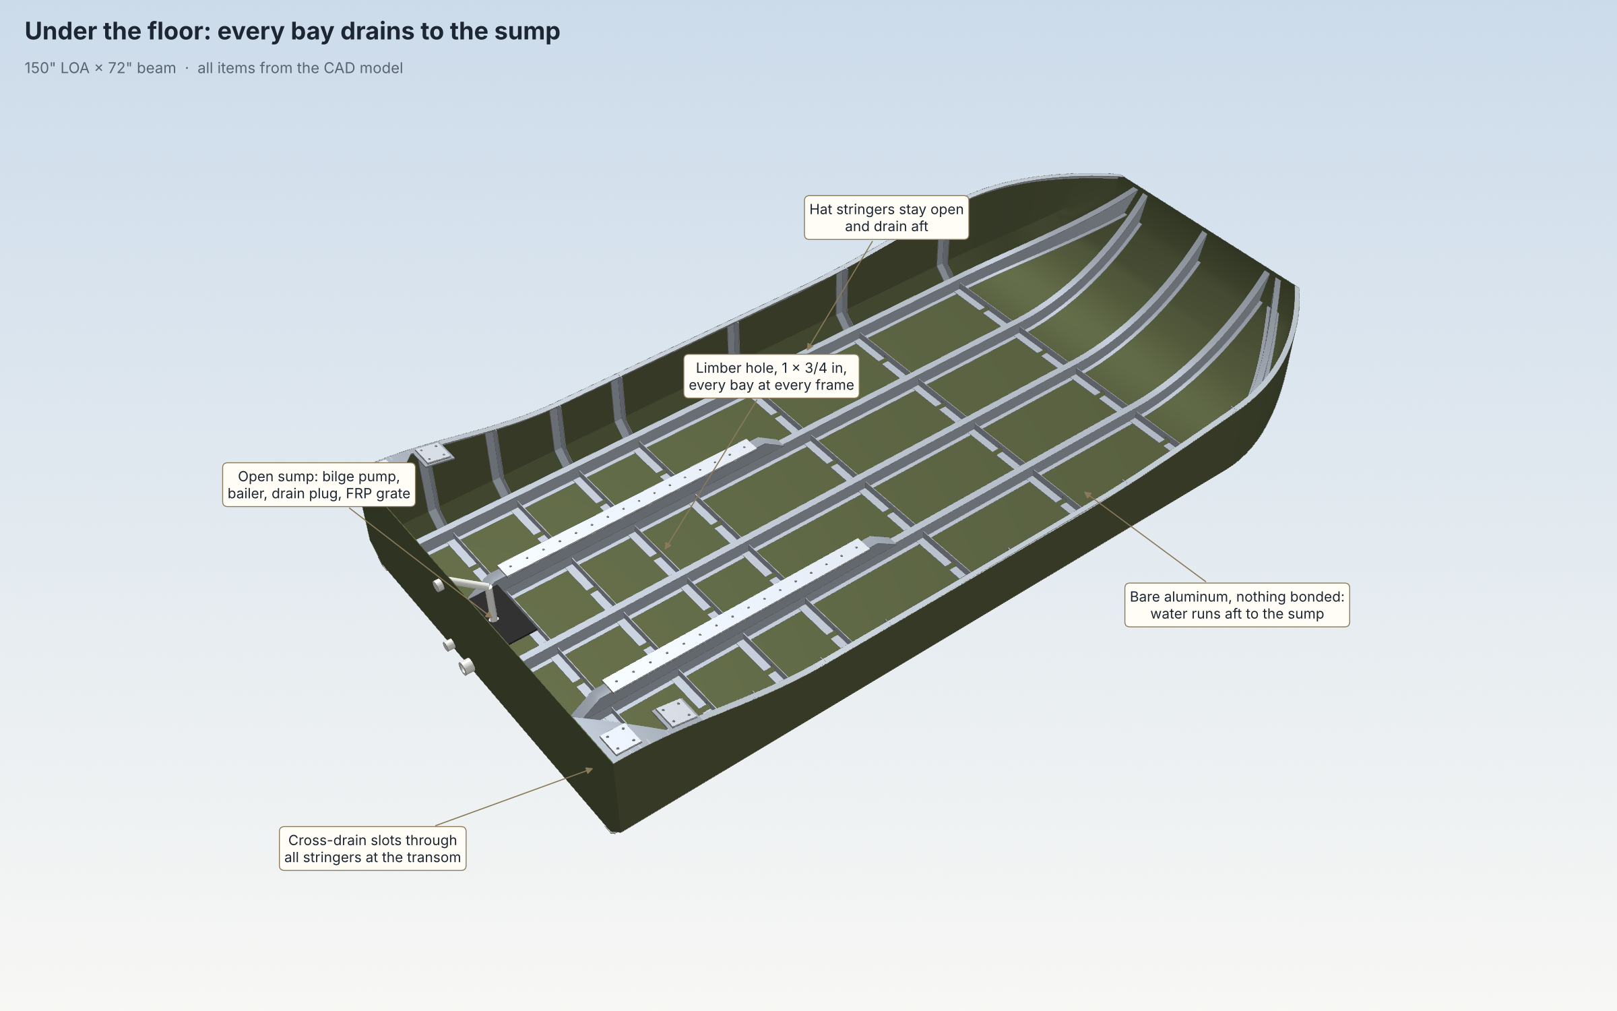
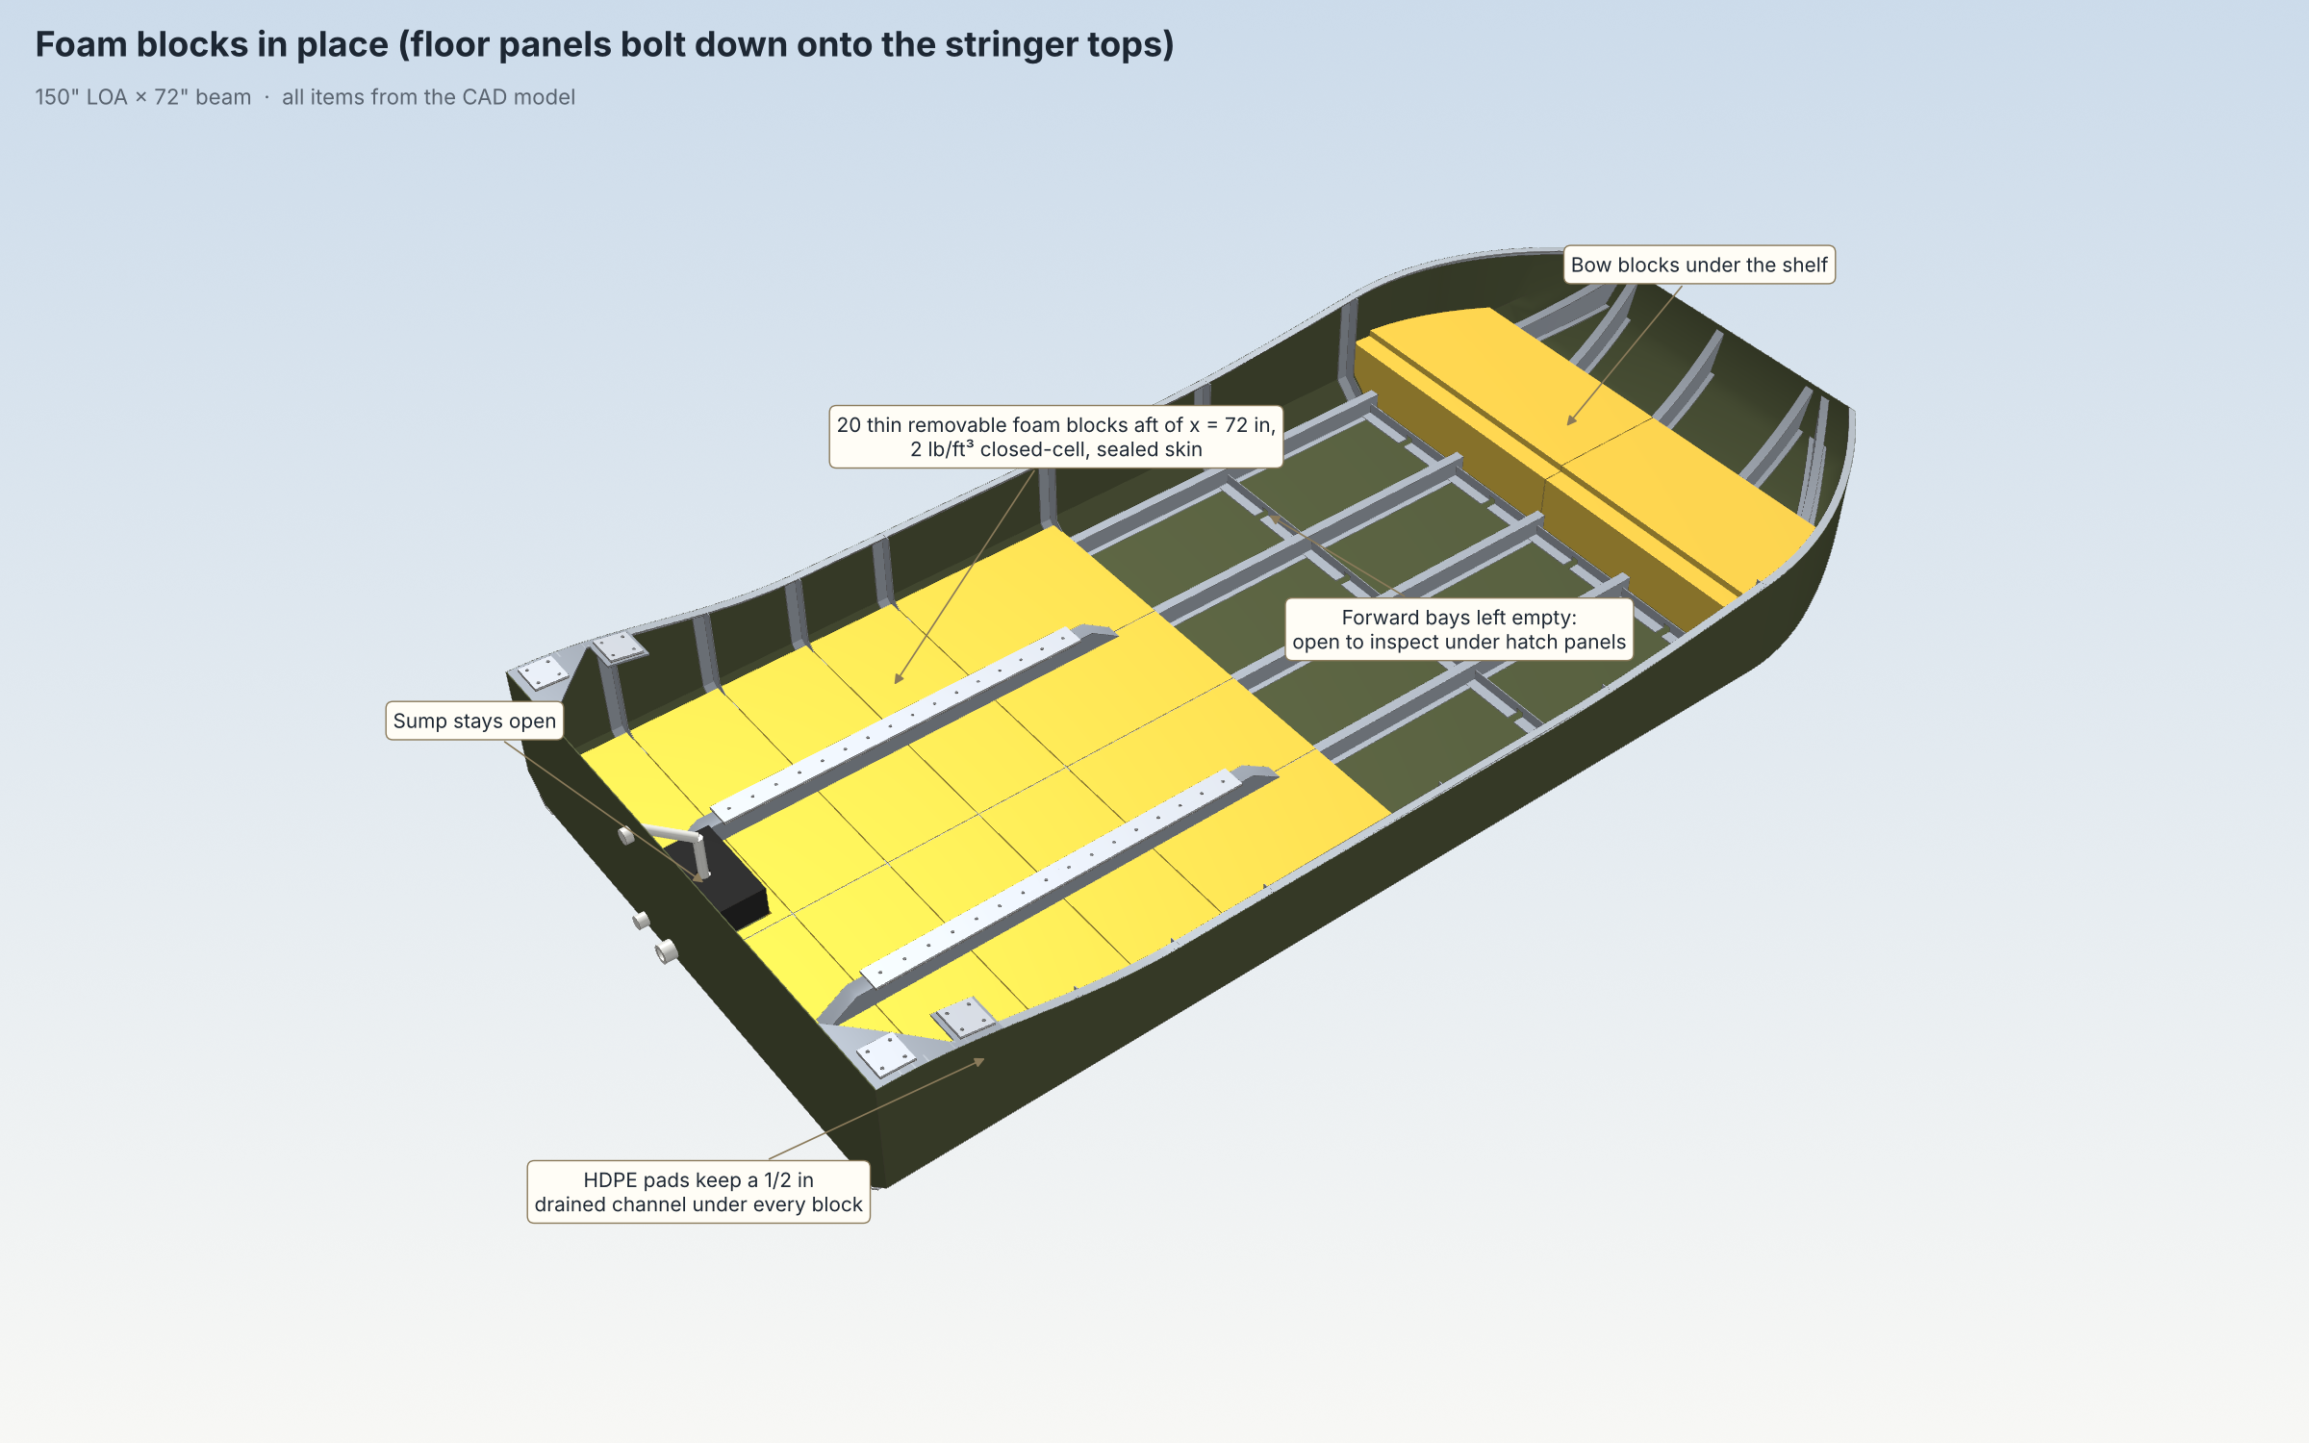
- Why the foam is aft: the engine, prop and cage put the weight aft. With no under-floor foam the swamped boat sinks by the stern (12.6°, transom under) even though the total lift is nearly enough; foam forward of x = 72 in would only add bow-up trim.
- Side blocks are essential: they supply most of the swamped stability. Strap them in whenever the boat is used.
- Load margin: each 100 lb of gear or cargo that doesn't float lowers the swamped boat about 0.9 in. Over about 200 lb of dense gear aboard, it can drop below 2 in.
- Foam blocks: 2 lb/ft³ closed-cell two-part urethane (gasoline resistant; never polystyrene), about 2 in thick between the stringers and frames, with 1/16 in clearance. Pour each on a release-lined 4 mm Coroplast tray (or in a mold), trim, seal-coat, and glue 1.5 × 1.5 × 1/2 in HDPE pads to the bottom so a 1/2 in drained channel stays under every block. Forward bays and hat-stringer interiors stay empty.
- Hold-down: the floor panels bolt down onto the stringer tops and hold the blocks down when swamped.
- Swamped freeboard at the sheer: 6.3 in at the transom, 3.5 in at x = 36 in (lowest), 5.0 in at x = 60 in, 6.4 in at x = 84 in, 11.5 in at x = 120 in. Without any foam the boat would sink, about 310 lb heavy.
- Sump and pump: open sump in the port bay at the transom (x = 1.7–10 in, down to the bare skin) under a removable raised FRP grate box, since the pump is taller than the low floor. Automatic bilge pump (about 1,100 gph, float switch) discharges through the transom at 14 in. A fused, waterproof auto/off/manual switch on the transom top lets you run it from the water when the boat is swamped; the battery is dry inside the sealed bench. A 1 in drain plug sits at the lowest point.
- Self-bailer: 1.5 in transom bailer at the bottom of the sump. It sits below the at-rest waterline (about 5 in at the transom), so it must have a working check valve and only drains underway if the transom unwets. Treat the pump as primary.
- Swamped, nobody can sit in the boat or bail it from inside; tow or walk it to shallow water and pump it out there. Capsize: the engine, prop and cage act like a keel when inverted, so righting by hand in deep water is unrealistic. Avoid hard turns at speed.

Finding and fixing leaks
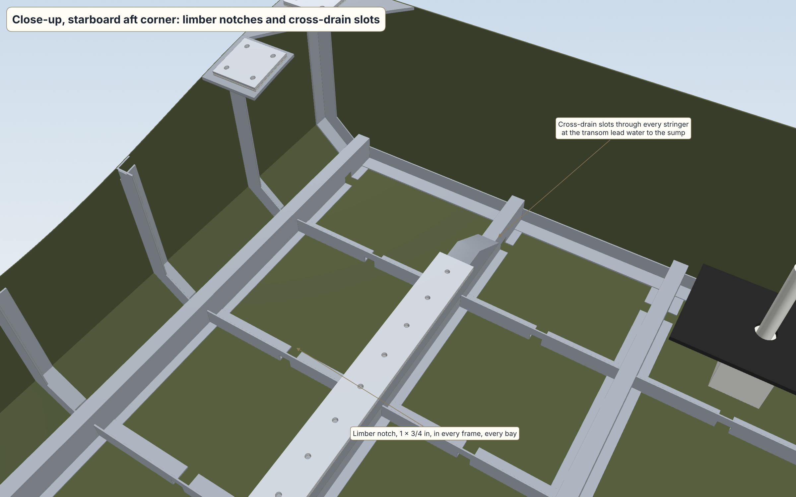
- Knowing there is a leak: a cycle counter or hour meter on the pump's float switch shows when it runs without rain, and how often. On the trailer, pull the drain plug after every trip; more than a cupful after a dry day is a warning.
- Finding the bay: pull the floor panel or open the deck plate over each bay. Water runs aft, so the wet bay with the driest bay ahead of it brackets the leak.
- Finding the rivet: on the trailer, fill the hull to 3–4 in with a hose and watch underneath for drips at the chines, seams and UHMW strip edges. Or, afloat, dry the bay with a blower and dust the rivet lines and laps with talc; a leak shows as a dark spot within minutes to hours. If it is under a UHMW strip, unbolt the strip and repeat on bare skin.
- Fixing it: drill off the rivet head, punch out the shank and set a new closed-end aluminum rivet with sealant on the shank, one size up if the hole is oval. Blind rivets can't be re-tightened, only replaced. A weeping lap gets cleaned to bare metal and brushed with Gluvit from inside, or is drilled out and re-bedded in Sikaflex. Fill-test again before the floor goes back.

Weight and balance
Distances are measured forward from the transom (x) and up from the hull bottom (z).
Group | Weight | LCG (x)
Hull (riveted aluminum, framing, UHMW, rails, mounts) | 331 lb | 67 in
Drivetrain (G13, belt drive, A-frames, mounts, prop, radiator, exhaust) | 385 lb | 27 in
Floor, bench, seating, controls, shelf, tank (empty), battery | 165 lb | 88 in
Prop cage and rudders | 85 lb | 3 in
Foam blocks, aft floor, sump, pump, deck plates | 72 lb | 42 in
Empty boat | 1,039 lb | 48.5 in (VCG 17.4 in)

Load case | Weight | LCG | Trim (bow up) | Draft at transom | Freeboard amidships
Solo, full fuel | 1,279 lb | 58.1 in | 1.0° | 5.1 in | 9.2 in
Solo, 1 gal fuel | 1,245 lb | 56.1 in | 1.3° | 5.3 in | 9.3 in
Driver + passenger, full fuel | 1,479 lb | 59.3 in | 1.0° | 5.7 in | 8.6 in
Solo + 100 lb cargo, full fuel | 1,379 lb | 58.8 in | 1.0° | 5.4 in | 8.9 in
At rest the boat sits slightly stern-down in every case, which suits planing off. Each inch the driver slides forward on the bench moves the trim about 0.16° toward the bow; the trim tab does the rest underway.

Assumptions and open items
The engine, bellhousing, radiator and prop are placeholders sized from published or typical figures; measure the real parts and update the CAD before cutting metal.
- Riveted hull: every lap bedded in sealant (Sikaflex 291 or 3M 4200), closed-end aluminum rivets only (never steel mandrel or open-end), double rows at about 3/4 in. Fill-test the hull for 24 h before the UHMW goes on and again after; mark and fix every weep.
- Galvanic isolation: Tef-Gel on all stainless fasteners in aluminum, HDPE pads under steel engine mounts, no copper, bronze or brass (including the drain plug) touching the hull.
- Weight: about 1,040 lb empty with the rev 6 joint hardware, about the same as the plywood version. Optional lightening: 3/16 in UHMW (about −21 lb), 0.080 in bottom (about −10 lb), 1 × 1 in frame angle (about −9 lb), 0.050 in sides (about −5 lb).
- Swamped flotation is a minimum, sized to float awash (3.5 in at the lowest sheer). Keep all 24 blocks and both side blocks in the boat, and don't add heavy gear without re-checking.
- G13 thrust (340 lb static with the 64R-TX-HPL3) is an estimate; confirm with a static thrust test on a scale before the first water run.
- Speeds use a simple planing model; real numbers depend on prop pitch, trim tab setting and load. Expect ±3 mph.
- Check state registration and any wildlife-area airboat rules before hunting.
- Performance numbers are estimates ±15%; final speed depends on real engine output, prop pitch setting and trim-tab setting.

CAD files, renders and sources
All files are in millimeters at true size and share one origin (outside of transom, centerline, hull bottom), so they import into OnShape and line up without moving anything.
File | Contents
DIY-Mini-Airboat_COMPLETE_assembly_r6.step | Everything below in one file (493 solids)
DIY-Mini-Airboat_hull_r4-2_aluminum.step | Riveted 5052 hull, 66 in flat + 3 in chine, hat stringers with cross-drain slots, frames with limber notches, engine beds with 52 in drilled plates, UHMW, rails, knees and cage plates
DIY-Mini-Airboat_drivetrain_r5_G13.step | G13, HTD 8M belt drive, A-frame weldments, clevis braces, tie struts, engine-mount cradles and brackets, prop, radiator and mounts, exhaust and hangers
DIY-Mini-Airboat_layout_r6.step | Low floor, straddle bench with sockets, clips and battery tray, handles, controls and steering pivot, ladder, bow shelf and supports, tank
DIY-Mini-Airboat_cage_rudders_r2.step | Coped prop cage on bolted, isolated pads; rudders on bushed pivots; rod-end linkage
DIY-Mini-Airboat_flotation_r5_aft72.step | 24 foam blocks (aft and bow), HDPE pads, side blocks, aft floor, deck plates, raised sump grate, pump, bailer, drain plug
The fabrication workbook (cut list, plates with DXF flat patterns, weldments, hardware, joint notes) and the plate DXF zip go with these files.
Reference renders for image generation come in clean, with posed riders, and annotated versions from four angles, plus three under-floor views.
Sources:
- Warp Drive 3-blade prop with HPL hub
- AirTrikes SPG gearbox (lists G10 / G13 / G16)
- Geo Metro 1.0 and 1.3 specifications
- Whirlwind mini airboat propeller
- Ace Aviation belt redrives
- Chalco aluminum honeycomb panel

